## **Lab_Day-8 ANP-C9180 (String)**

**Q1. Write a Python program to count the occurrences of each word in a given**

**sentence string = “To change the overall look of your document. To change the look available in the gallery”**

**Sol:**

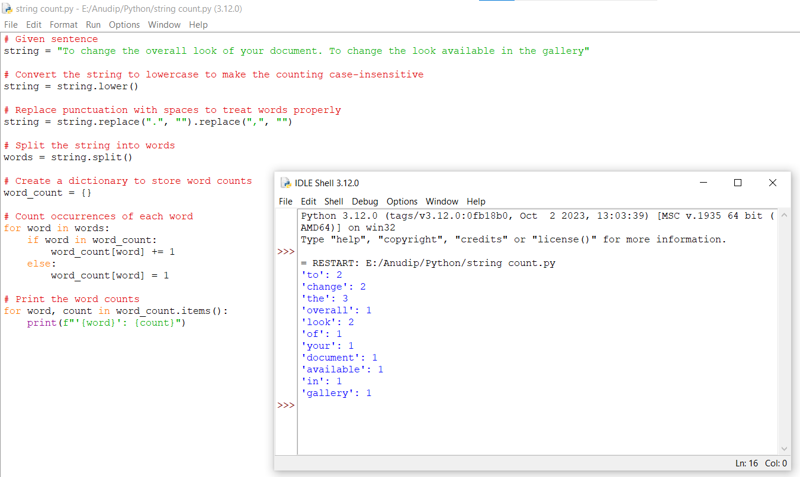

**Q2. Write a Python program to remove a newline in Python**

**String = "\nBest \nDeeptech \nPython \nTraining\n"**

**Sol:**

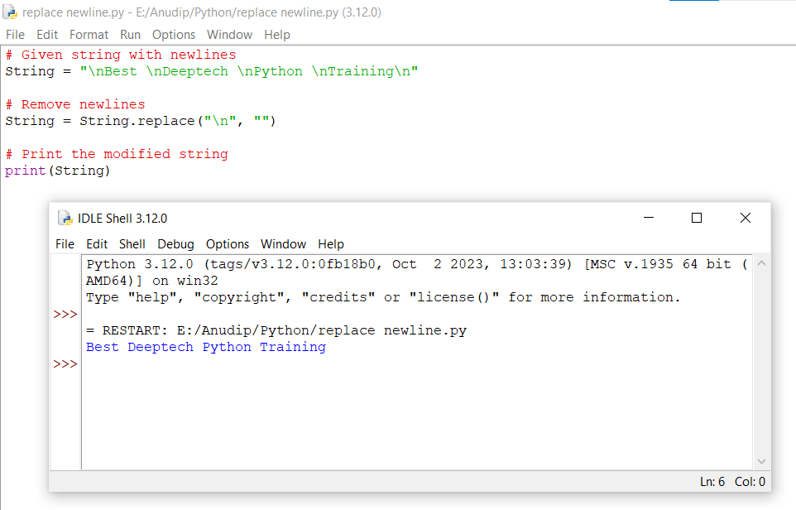

**Q3.Write a Python program to reverse words in a string**

**String = “Deeptech Python Training”**

**Sol:**

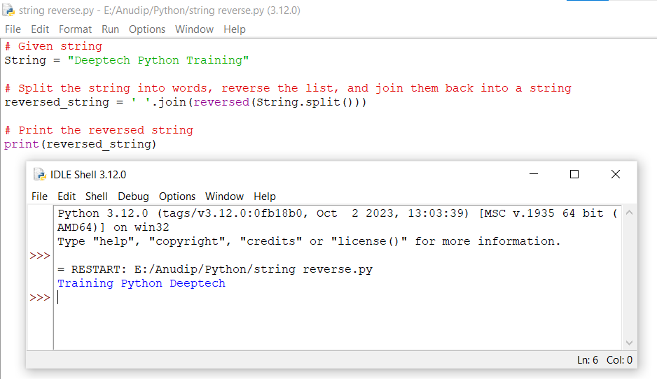

**Q4.4. Write a Python program to count and display the vowels of a given text**

**String=”Welcome to python Training"**

**Sol:**

